Appointments booked between 1st June – 31st August 2022 = 9676

Face to Face appointments = 5086 Prescriptions requested = 5528
Telephone appointments = 4622 Telephone calls received = 21957
Other = 17
DNA - 194

Appointments booked between 1st September – 30th November 2022 = 15412

Face to Face appointments = 8781 Prescriptions requested = 7754
Telephone appointments = 6569 Telephone calls received = 26649
Other = 210
DNA = 433

Appointments booked between 1st December – 28th February 2023 = 15376

Face to Face appointments = 9176 Prescriptions requested = 7006
Telephone appointments = 6018 Telephone calls received = 28549
Other = 217
DNA = 323

1st June to 31st August 2022 General Practice Workload
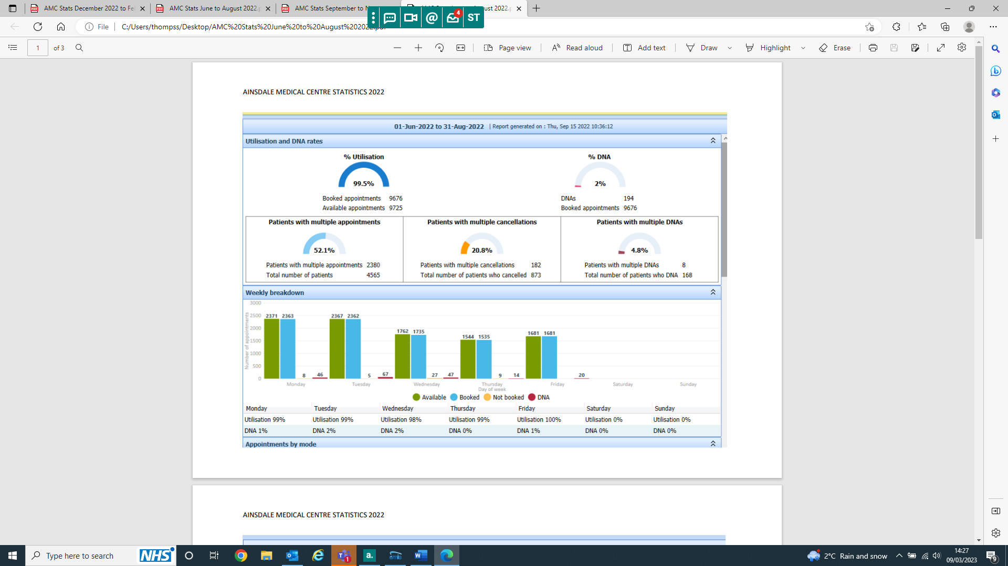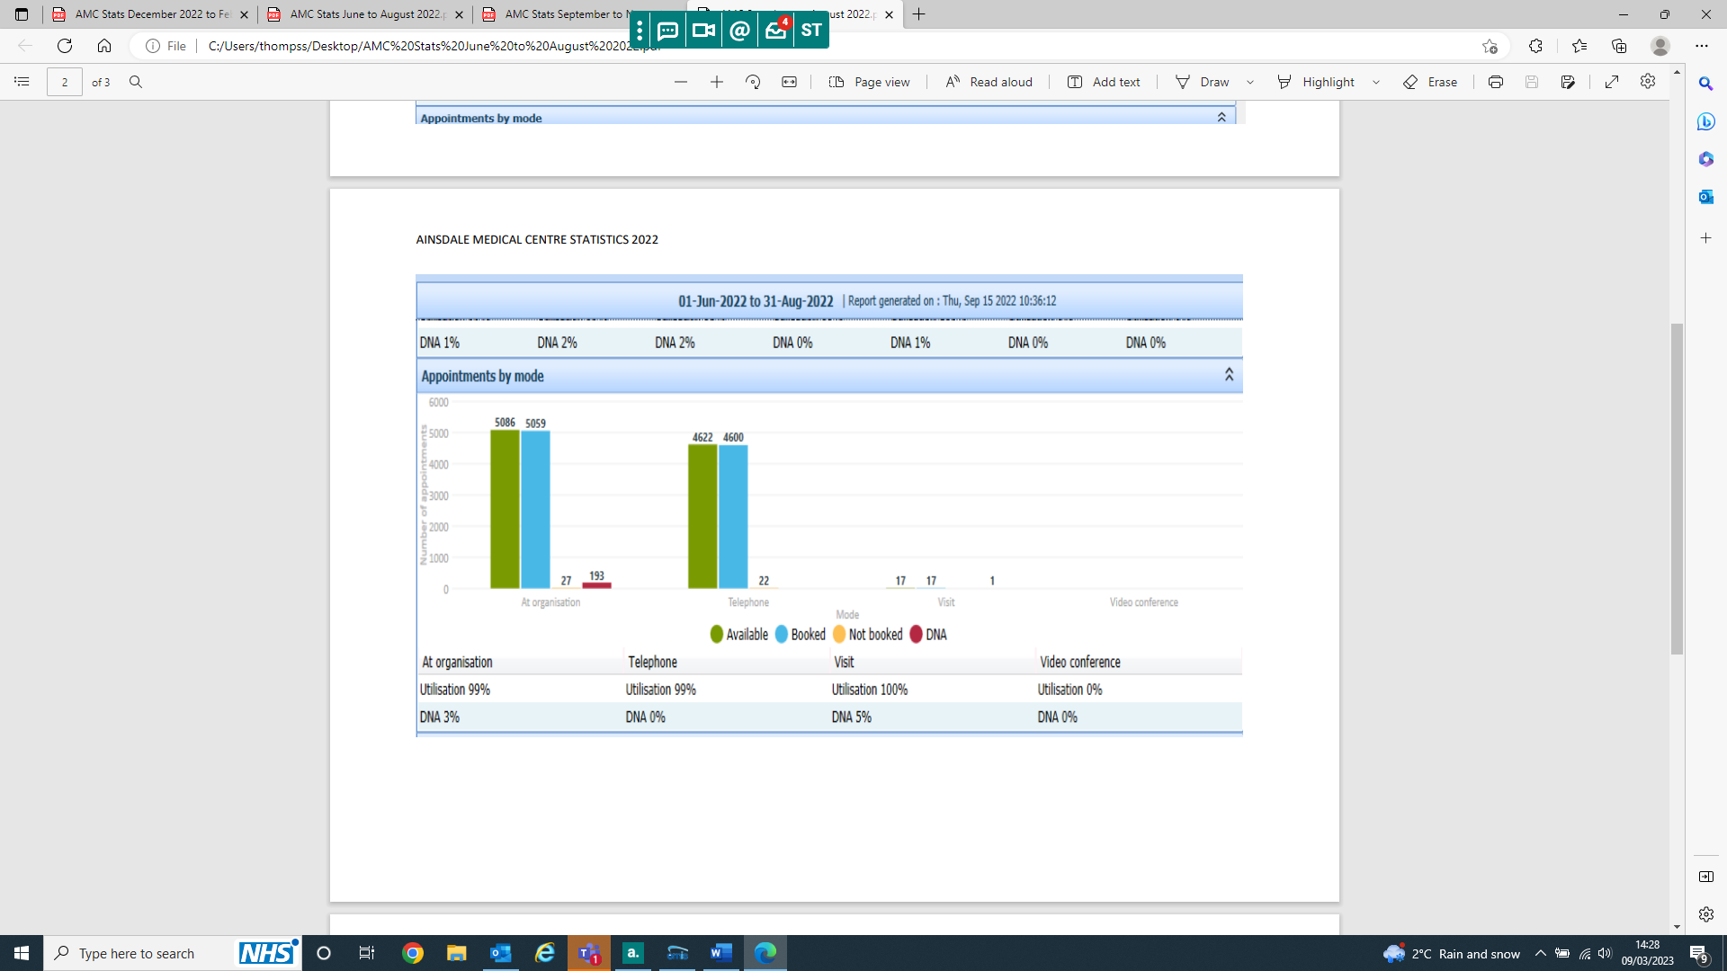
1st September to 30th November 2022 General Practice Workload
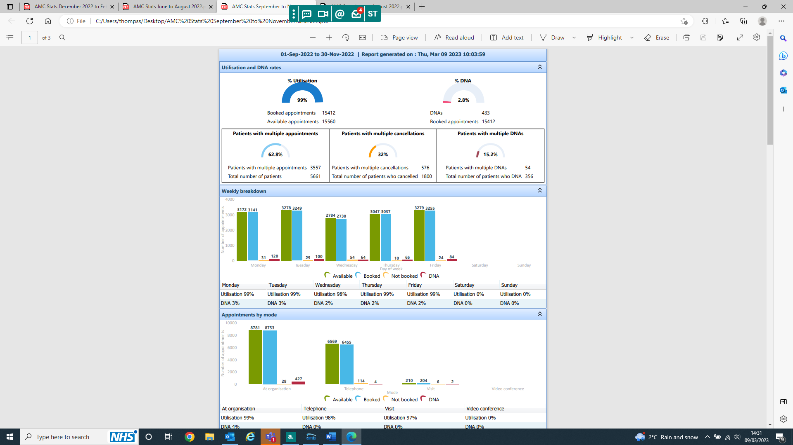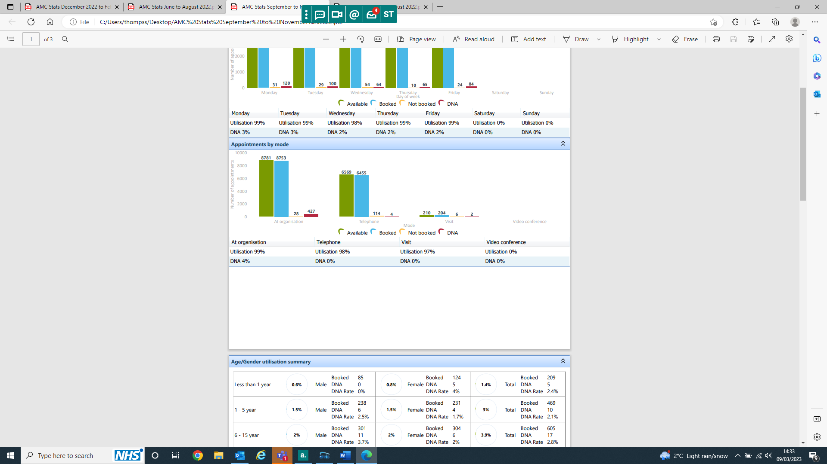
1st December to 28th February 2023 General Practice Workload
